3).Create a simple cloud software application for Car Booking Reservation System using any Cloud Service Provider to demonstrate SaaS include the necessary fields such as search for cabs, from, to, rental , out station, Package type, hours/Days etc

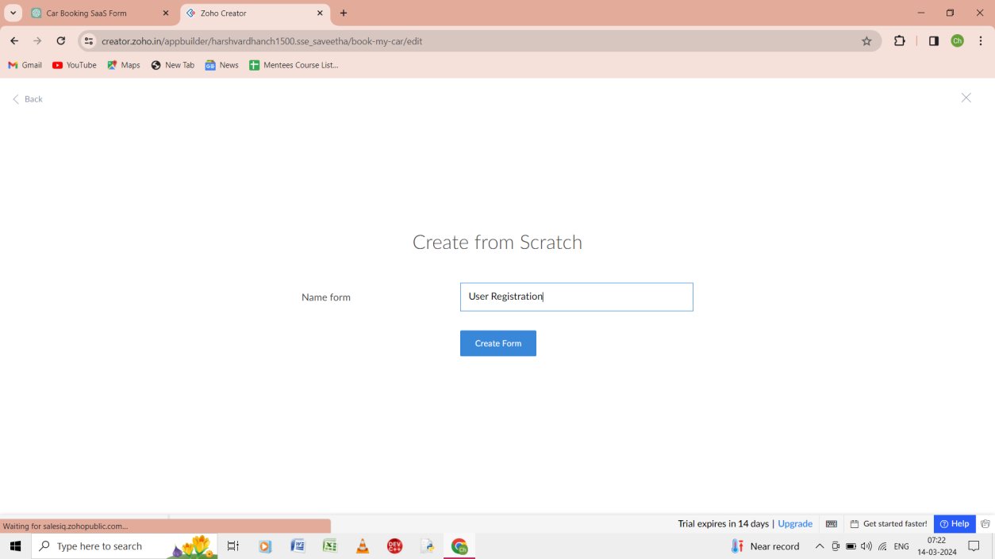

Step 1: ftom scratch give the form as the user registration .

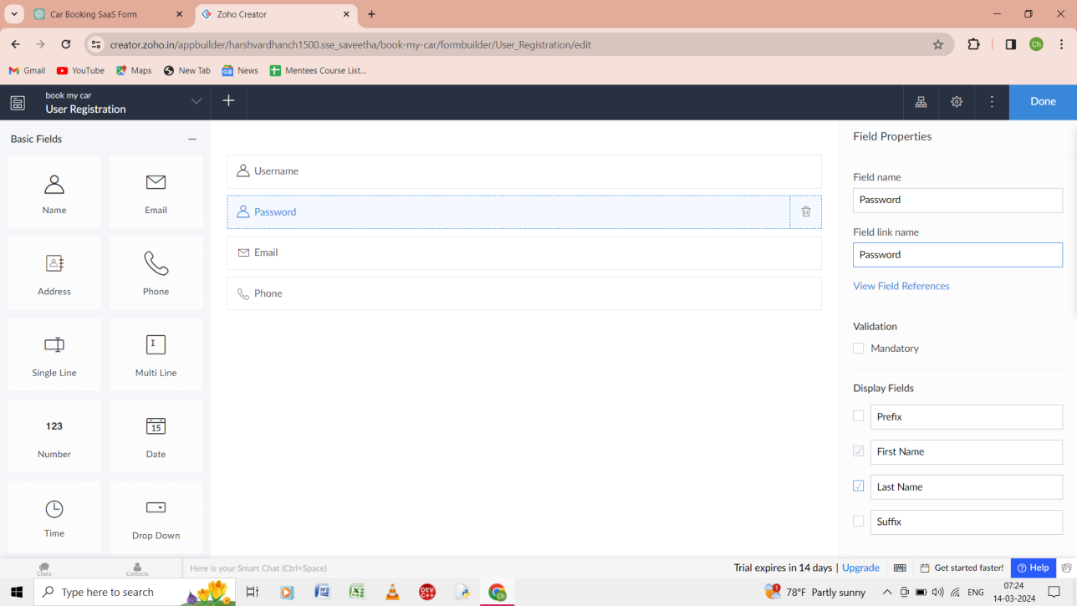

Step 2: give the username , password, email, phone number for the user registration form.

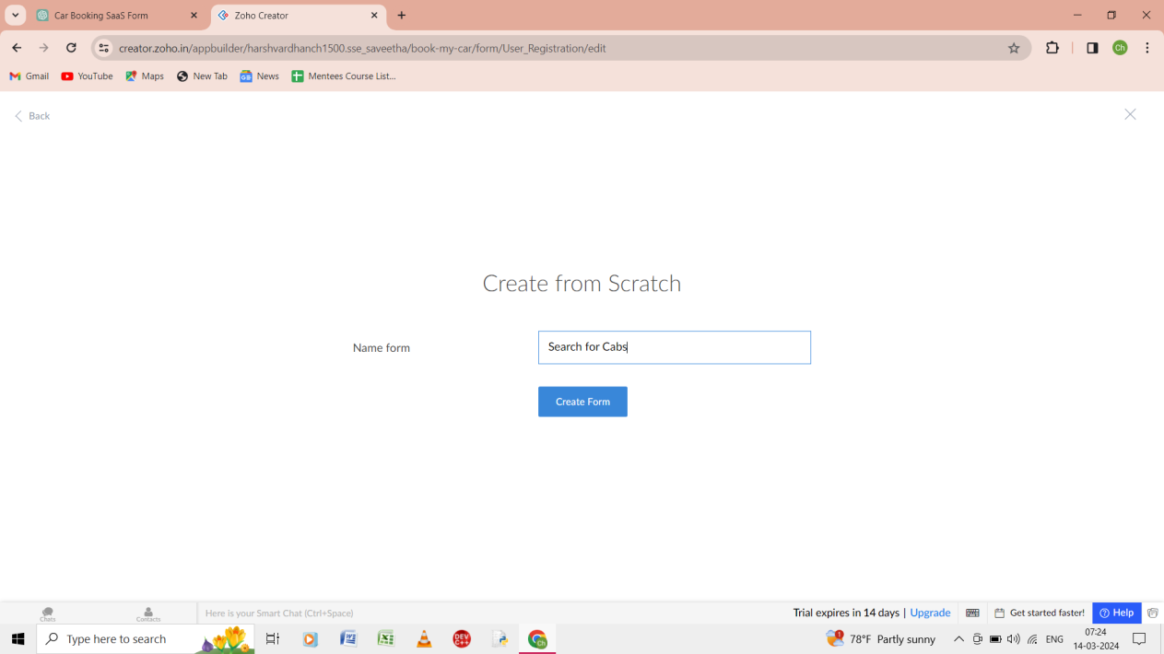

Step 3:from the scratch give the name of the form as the search for cabs.

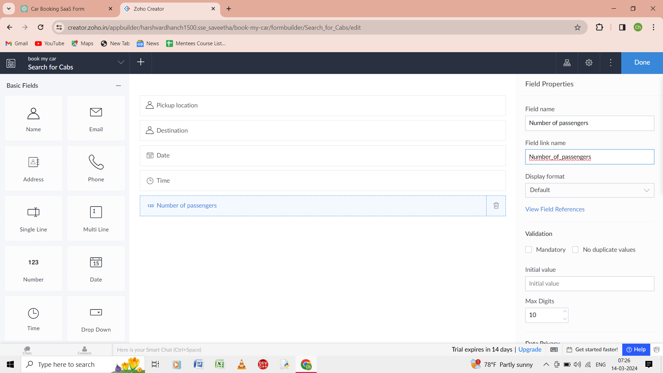

Step 4: Give the details of the form as pick up location, destination, date, time, and number of the passengers.

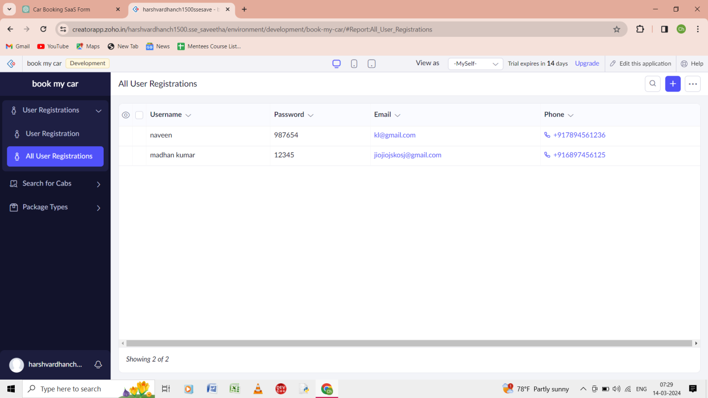

Step 5: the output of the all the user registration in the form.

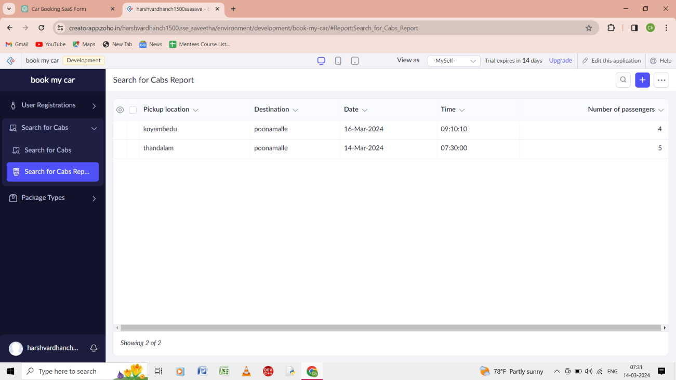

Step 6: the output of the search for cabs in the forms.

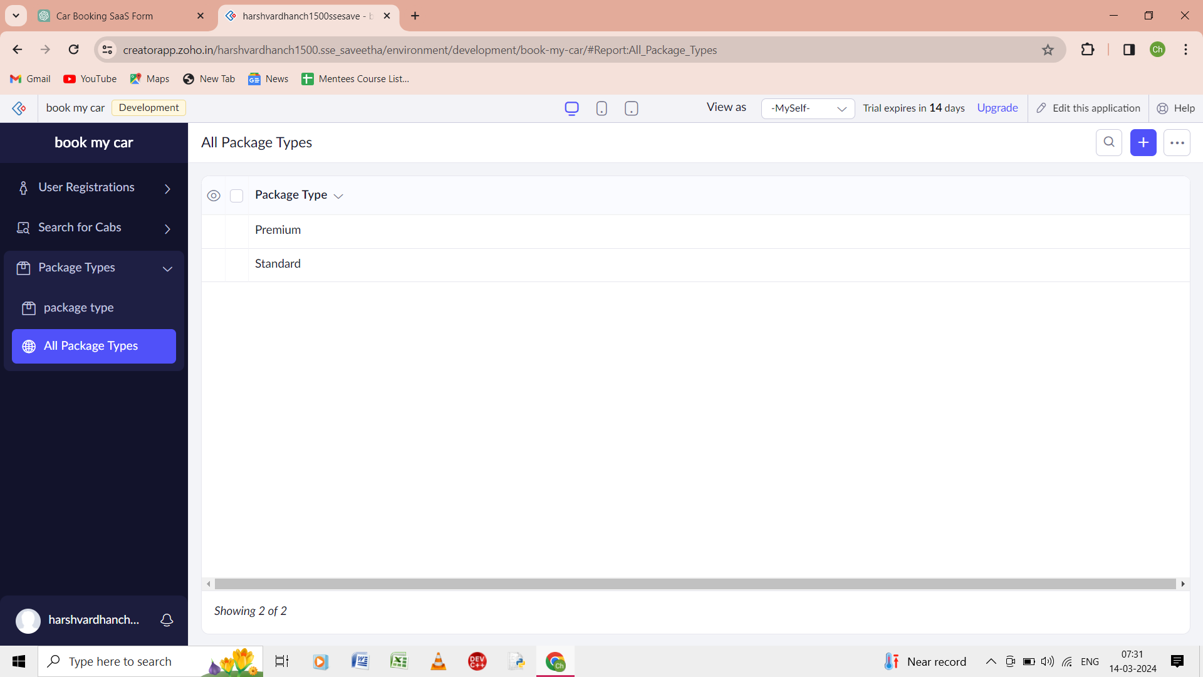

Step 8: the output the form of the all packages types in the form